Social Justice and Equity Action Plan
Naming the Problem:
One of the most pressing issues at Paloma Valley High School is the lack of efficient placement of students. Many students have not been situated in the right classes, thus subsequently it has contributed to a constant switch of student’s courses throughout the semester. Another big issues has been that teachers are not provided much information as to give insight into their student’s educational needs. There is much discretion and many of the students information is not distributed to the staff (particularly teachers). This is especially an issue when it comes down to the 504 Plan, IEP, and EL students, since many teacher are kept wondering what their needs and struggles are. These are matters of concern that I would like to address.
Critical Reflection:
If you look at the research based on the placement of students in California’s secondary schools, particularly in terms of or EL students, you will find many flaws. For instance, the primary place “Long Term English Learners” are situated in are “’mainstream’ classes…mixed with English proficient students” and instructors often unaware of the “English Learners in their classes” (Olsen, 2010, p. 27). Of course, this ignorance to their students’ ability levels is a significant problem, but what about when you add on to this ignorance with great diversity within the class? Essentially, there is also evidence that many classes range “from non-English proficient (no English) to honors level students,” which is very difficult for teachers to adhere to when unaware of their student’s learner profiles (Olsen, 2010, p. 27).
Considering that most schools will place EL students based on their level of English proficiency as determined by CELDT tests, there is a major problem (Dutro & Kinsella, 2010, p. 166). This is because the CELDT testing is inherently flawed. For one, it frequently initially tests kids at the ages of 4-5 years old, most often based on “if their parent or guardian included any language,” despite that many young kids will naturally struggle with language development in one way or another, early on (Zhao, 2011, p. 1). Plus, since students get tested in terms of listening, speaking, reading, and writing; many students who will develop to be perfectly fine might have a bit of a hard time in at least one of these areas at least early on, and mistakenly be labeled an EL student and unnecessarily going through the process for a set amount of years (California Department of Education, 2015, p. 1-2). Then there is the issue of cultural awareness, particularly for students from other cultures and countries, whether they had prior schooling or not. We must therefore find out students backgrounds as best as possible, because cultural awareness makes cultural responsiveness easier, thus allowing teacher to adjust their teaching styles, interaction patterns, how to work with parents, and so on (Diaz-Rico & Weed, 2006, p. 262).
Considering all this, I also talked to my fellow teacher candidates at the school site, my CT, several other history teachers, and my assist class teachers, and they all agree that there is a problem with student placement and teacher awareness of needs. I can say that with my CT, we have found that it has been a difficult and slow process to get ideas about our special needs students, especially out ELs, making it difficult to plan for them. Particularly in the class I assist in, however, there has been a huge issue with placement of students, and virtually all of them have IEPs, though the class is a mainstream one. Despite the mainstream label, student’s reading levels vary widely from kindergarten level to a sixth grade level. The placement in this class has been hectic with new students coming in or going out even after about 7-8 weeks in the semester, and they recently lost 2 students, to be placed in another class.
Action to Take:
I propose that we create and conduct a campus wide survey provided to each teacher (perhaps through Google Forms), that can be administered to the students to get greater insight to their learn habits and needs. This would be prepared before the school year and then conducted at the beginning of the year for the purpose of making student placement a smoother process through awareness. With this, students can get the help that they need and deserve more effectively. The first day of school this year was a planned day where all teachers had to show videos and cover the school handbook. It was planned out as a way to get students acclimated to school policy, graduation requirements, and so on. In this sense a schoolwide survey seems to be a reasonable expectation and action to hold on the first day or two of the next school year.
Students that are not present the first couple days of school can easily make up the survey and be assessed at a later date. The results of the survey will accordingly be overviewed by teachers who can plan based on their newly acquired knowledge, as a means to start adjusting their instruction based on individual student needs. Additionally, this information is to be shared with the counseling office to best determine where students are to be placed. Teachers can help provide their input on where they believe the students should be placed based on the results and their early observations. It will undertake the needs of all students, but be particularly geared to best helping IEP, EL, and other special needs students. Such actions displays an effort to ensure the best placement possible.
I also propose that there also be follow up surveys as well. These follow-ups will be check-ins for teachers to see student progress early in the year, and incorporate questions targeting student opinions on what they feel is helping or hurting them in class. Additionally they will address what students’ struggles are, their learning preferences and profiles (revolved around Howard Gardner’s multiple intelligence theory), and what they would like to try out or adjust. Ideally these follow up surveys will help teachers determine how to adjust their instruction, and/or counselors get an idea of how to change students’ classes before it is too late. This can help teachers in given subject areas determine which classrooms students will potentially benefit most from.
Timeline
The survey is to be administered on day 1 and 2 of the school year. A follow up survey will be held at the beginning of the next week, and then at the beginning of the next weeks to follow for about the next 3-5 weeks. New students will receive a survey as they enter the school and will also receive weekly follow ups for about 2-3 weeks.
Types of Questions
Questions that will be asked include student ID # (or name); interests; first language; language spoken at home; learning preference or strengths (i.e. Howard Gardner’s multiple intelligences—visual, auditory, kinesthetic, interpersonal, intrapersonal, etc.); CELDT/EL level (if know by student); IEP levels; Learning disabilities (if known, particularly for ELs & IEPs, as well as 504s); prior aids or differentiation provided to them, if applicable; general preferred or disliked forms of instruction students have; and even medical issues or concerns they want the teacher to know about, as to be handled accordingly.
Link to initial survey: https://goo.gl/lfxuze
Link to follow-up survey: http://goo.gl/forms/LCB3dL5d77
*Not that this is not a survey under the district email, yet if PVHS chooses to adopt a survey of the sort, it will be administered to only people in the district email circuit (not open to anyone with the link as these ones).
*Additionally teachers are to be provided picture graphs as the ones below to help them explain the multiple intelligences to students before the survey is administered. This will hopefully help students accurately fill out their surveys as effectively as possible.
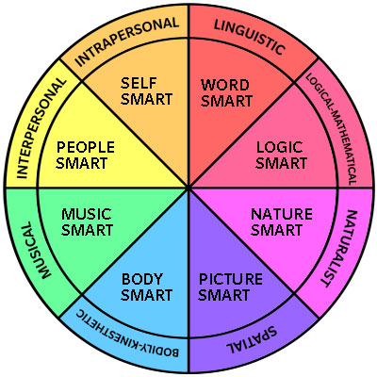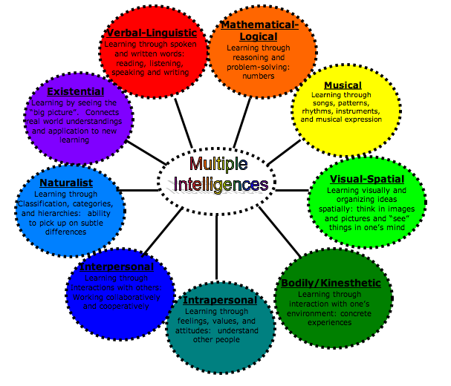

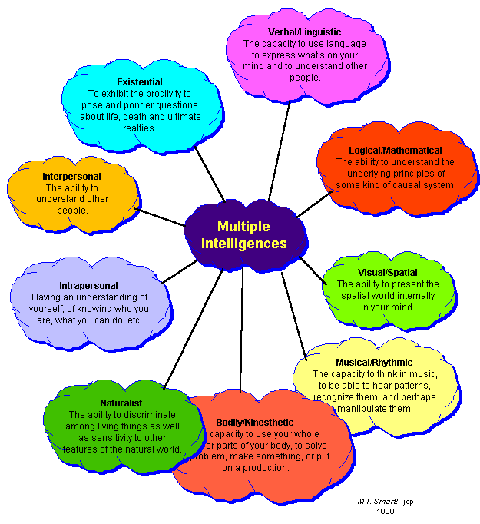
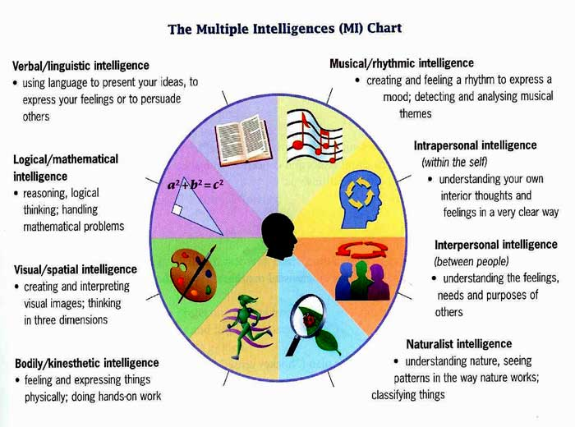
TPE 15 Reflective Statement:
I would say that one of the primary, if not “the” primary issue at my school site, is effective placement and knowledge of student needs. Without these two things there essentially is a lack of social “equity in the classroom.” In addition, teachers will struggle to provide “appropriate instructional strategies” for the opportunity of all students to have “equal outcomes.” These surveys I designed will ideally lead my school site to move one step closer to producing “equitable outcomes,” particularly for students from “different linguistic” and “cultural” backgrounds. Additionally, this action would help teachers and staff members further “collaborate with” each other, to improve educational opportunities as much as possible. I attempted to ask questions that will enlighten teachers, and in turn the school staff, as to student learning profiles, as a way to try and help provided instruction and classes best fit for students to receive an equal education experience. In this sense, I believe that this action plan answers to the TPE 15 Social Justice requirement.

References:
California Department of Education. (2015, April 13). Frequently Asked Questions about the California English Language Development Test (CELDT).
Diaz-Rico, L., & Weed, K. (2006). The CLAD Handbook: A Complete K-12 Reference Guide. Boston, MA: Pearson.
Dutro, S., & Kinsella, K. (2010). English Language Development: Issues and Implementation at Grades Six Through Twelve. Improving Education for English Learners: Research- Based Approaches (pp. 151-187). Sacramento, CA: CDE Press.
Olsen, L. (2010). Reparable Harm: Fulfilling the Unkept Promise of Educational Opportunity for Long Term English Learners. Long Beach, CA: Californians Together.
Zhao, E. (2011, September 19). California English Proficiency Test 'Almost Guarantees' English Learner Classification, Study Shows. HuffintonPost.com. Retrieved from http://www.huffingtonpost.com/2011/09/19/california-english-profic_n_970582.html

